Bare Skinz
Week #2
Gordon Elliott Williams
Post University
Sunday, February 7, 2021

Table of Content
Part 1
Product Selection 3
Company Name 3
Competitive Analysis 3
Company Logo 4
Part 2
Segmentation Process 5
Approach to Positioning 5
Budget Setting 6
Part 3
Messaging Strategy 5
Appeal Selection 7
Mock Design 7
Part 4
Narrative 8

Product Selection
The product selected for this project will be a new product completely unheard of in any market whatsoever. I present to you, the ‘Bare Skinz’ safety glove. In this new age where we are extremely safety conscious due to our current pandemic with Covid-19, this product will revolutionize safety protocols in the sporting, industrial, and farming industries.
Company Name
The company name chosen will be identical to its first product name, ‘Bare Skinz.’ The rationale for choosing the first portion of the name is partly based on the male dominated markets in specific sports, dirty industrial occupations, and one of the hardest and most unclean occupations of all, farming. The rationale for the second portion of the name is because the product will feel like a second skin worn under their current work gloves.
Competitive Analysis
The closest product that is on the market would be considered nitrile or trauma gloves. The three highest rated nitrile disposable gloves (as tested by www.reviewed.com) are ‘Venom Steel Rip Resistant Industrial Nitrile Gloves, Curad Powder-Free Textured Latex Exam Gloves, and the Safety Zone Powder-Free Nitrile Examination Gloves. While nitrile gloves are meant to protect a wearers hands and safe from contamination, they are primarily used in the medical and food industries. These gloves are meant to be marketed towards (a) the sporting athlete that wears gloves (billiard players, bowlers, football players, baseball players, soccer players, cricket players, and even golfers), (b) the industrial worker (i.e. plumbers, oil rig workers, sewer inspectors, die casters and forgers, automobile mechanics, the military, crime scene cleaners, painters, and trash handlers), and (c) those who work in the farming industries (i.e. pig slop processors, meat processors/slaughter, gardeners, and fishermen). The biggest trend transferring from 2020 to 2021 is extreme cleanliness and safety from germs. So, it appears that this could be creating an entirely new niche market with no immediate competitors.
Company Logo
The logo design chosen was picked online from a selection of bears. The goal was to present something that had a modicum of toughness to attract the men, but not so much that it was not appropriate for women. I think the reaction will be a positive one comparable to a straight, black cup of coffee on a cool fall morning. Ideally, we would use a different bear for each glove marketing area (i.e., the polar bear for cold jobs, the grizzly bear for watery jobs, the Kodiak bear for the dirtiest jobs, and possibly the black bear for special jobs).

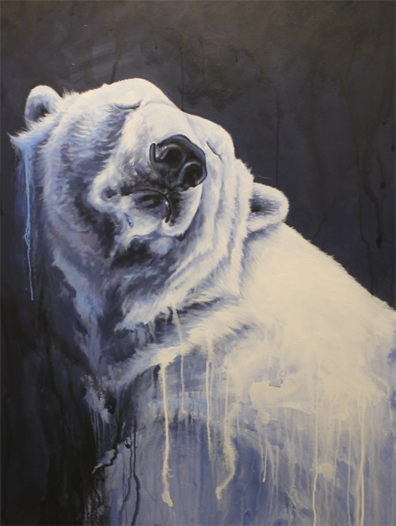



Segmentation Process
The segmented groups that we have chosen from our readings will be primarily geographical and demographical (Yesbeck, n.d.). The subset under the geographical market segmentation will focus its target audience based on locations and climate, while the demographical market segmentation will have a target audience circling around occupation and possibly gender. The rationale for the initial choice is because this product is to be used underneath their regular work gloves, as a second skin, that gives an additional layer of protection. That layer of protection will vary in thickness based on the climate and location. The latter choice is because the occupation can verily differ in the need of which ‘Bare Skin’ is most appropriate. Now, the only way to make the gender appeal to both sides of the marketing aisle would be using different color schemes. I think that in this age of extreme safety, all segmentation approaches will be extremely effective, depending on the type of advertisement used to attract the consumer.
Approach to Positioning
Our strategic approach to positioning will need to create an image of the ‘Bare Skinz’ product that will be the most profitable. Our positioning can be based on its specific characteristics (Hopper, 2020). This glove is to be as sheer as a traditional nitrile trauma glove, but instead of using powder, it will be slightly dipped in a sanitizer on the interior, with small suction buds on the exterior to grip against the workman’s/athlete’s normal work glove. Our next positioning will be based on the product application and usage (Hopper, 2020). As previously stated, the target will be primarily in male-dominated, strenuous, extremely dirty jobs. The goal is to emphasize that no matter how hard or dirty the job is, they will always come out clean and sanitized. The current market share potential is astronomical if we can ensure our product is manufactured and distributed as lean as possible. This can be achieved by owning the manufacturer plant and have co-ownership in the distributors. One tantamount goal is to use American workers in every step of the MRO supply chain process. The ‘American Made’ moniker is that still rings a positive note around the world, and with our new administration, it will be able to be an even stronger symbol of quality workmanship. Realizing that a customer never simply ‘buys a product’, we will need to repeatedly communicate our vision and values to make sure it is the right fit for each market. We will present ourselves as the small American dream startup out of a garage in a small town. This will emphasize value, hard work, and integrity.
Budget Setting
Any budgeting methodology must begin with an operating budget and an operational budget to give yourself a complete overview of the funds coming in and out. Because we are a small startup with limited funds, we will initially use a zero-based budgeting (Holdaway, 2020). Until we can achieve an investment or high-dollar loan, we will need to economize and extremely trim our budget of excess spending (i.e., no Starbucks coffee and a lot of lunch-and-learns). If we do attract a serious investor or receive a quality bank loan, we will probably change to a surplus budgeting style. This will allow us to reinvest a portion of the EBIT (Earnings Before Income and Taxes) and using the newly received funds for the purchase of better equipment.
Messaging Strategy
Our key strategy is to develop a believable message that can cross all sexes, races, and age groups. We desire to be extremely believable with the ability to relate to anyone from the construction worker in the foundation mud pits to the CEO in the $4,000 Brunello Cucinelli hand-tailored suits. It doesn’t matter if you are a community college racquetball student or an Ivy League oarsman, Bare Skinz products will gain credibility and become more and more interesting with each commercial or social media marketing campaign. At a minimum, we will be the most distinct product on the market for our uniqueness as a brand new product on the market undeveloped ever before. By positioning ourselves with athletes like ex-NFL running back Jim Brown, or Nick Gowitzka of Wicked Tuna, or even Bear Grylls of Man vs. Wild, “it's our communication methods, and it influences whereby every bit of text connected to our business, from in-store signage and advertising to customer support emails and web copy (How To Build An Effective, n.d.).”
Appeal Selection
Our primary goal, as with any successful advertising campaign, is to connect with our audience with a creative appealing marketing campaign. The type of appeal will strictly vary on the audience we market, which will also depend on the type of gloves we market. For example, we would probably use the musical appeal for our gloves marketed towards ballet dancers, NFL football players, or anything where there is a synchronization. But for the high-rise construction workers, or the deep-sea tuna fisherman, we may use the fear appeal. But to make that middle of the road audience who works their 9 to 5 jobs and the hardest thing they do is swing a hammer at home in the garage, we would a combination of the appeals of humor and emotion (Folliero, 2018).
Mock Design
Our mock design will be simple, yet emphasize toughness. We will focus on television advertisement during the toughest television shows such as WWE Monday Night Raw, America’s Toughest Jobs tv show, or police shows like SWAT or Chicago PD, or military dramas such as SEAL Team. “SEAL Team averages 5.23 million viewers in adults age range 18-49 and SWAT has similar age ranges with about 3.8 million viewers (Porter, 2020). In each of these shows, gloves are nearly always worn during their daily functions. What a great opportunity to pay for a product placement.”

Narrative
Bare Skinz is all about ‘realness’. So may times when we use social media or listen to our fiends talk, we always hear about ‘keeping it real’ or ‘keeping it 100.’ Todays audience takes a special amount of pride with realness and that’s how we want our product to be featured. Not as some gimmicky gadgetry that comes and goes with the times. But something that is long-lasting and helpful in the average American’s day-to-day work experiences. We want to appeal to everyone that has a special part in making our country great, from the janitor working overnight on the college floors, to the plumber working upside down to fix your busted pipes after freezing temperatures. Everyone should be able to relate to and understand the value of Bare Skinz gloves and safety products.

References
Yesbeck, J. n.d. “4 Types of Market Segmentation With Examples.” Retrieved from: https://blog.alexa.com/types-of-market-segmentation/
Hopper, D. 05 Aug 2020. “Positioning: 5 Strategies To Stand Out From Your Competitors.” Retrieved from: https://www.business2community.com/strategy/positioning-5-strategies-to-stand-out-from-your-competitors-02333056
Holdaway, D. 06 Aug 2020. “What Are The Different Types of Business Budgeting Methods?” Retrieved from: https://getdivvy.com/blog/types-of-business-budgeting-methods/
How To Build An Effective Messaging Strategy. N.d. Ring Central. Retrieved from: https://www.ringcentral.com/us/en/blog/messaging-strategy/
Folliero, T. 18 Sep 2018. “Seven Appeal Strategies For Your Advertising Campaigns.” Retrieved from: https://smmadvertising.com/seven-appeal-strategies-advertising-campaigns/
Porter, R. 26 Mar 2020. “TV Ratings: ‘Chicago Med,’ ‘Fire’ Draw Biggest Audiences Since 2015.” Retrieved from: https://www.hollywoodreporter.com/live-feed/chicago-med-survivor-tv-ratings-wednesday-march-25-2020-1286793

